Chapter 7 Elements
extra worksheet 3: Atomic symbols and electron configurations
Science understanding Verbal/Linguistic, Visual/Spatial
Name: Class: Date:
Atoms are made up of a positively charged nucleus surrounded by cloud of negatively charged electrons (charge -1), as shown in Figure 7.3.1. The nucleus is made up of two sub-atomic particles known as protons (charge +1) and neutrons (charge neutral).

Figure 7.3.1
The number of protons in the nucleus determines what type of atom it is. For example, all helium atoms have 2 protons; all carbon atoms have 6 protons and all gold atoms have 79 protons. Therefore the number of protons in the nucleus is referred to as the atomic number.
The number of protons and neutrons in the nucleus determines how heavy the atom is. The electrons can be ignored because they are about 1800 times lighter than protons and neutrons. For this reason, the number of protons and neutrons in the atom is known as the atomic mass.
All of this information is summarised by the atomic symbol, which includes the chemical symbol for the element. Below is the atomic symbol for an oxygen atom with 8 protons and 8 neutrons.
atomic mass → | 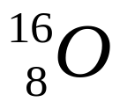
atomic number →
All of the atoms in an element must have the same atomic number. However, the atoms may have different atomic masses. In other words, all atoms in an element have the same number of protons but may have different numbers of neutrons. For example, all carbon atoms have 6 protons. Most carbon atoms have 6 neutrons so have the atomic symbol 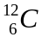. However, a small percentage of carbon atoms have 7 neutrons so have the atomic symbol 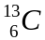. Others may have 8 neutrons so have the atomic symbol 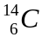. Atoms with the same atomic number but different atomic masses are known as isotopes.

Questions
1 Identify the nuclei in Figure 7.3.2 that match the following atomic symbols.
a  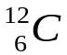 | b  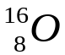 | c  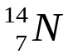 | d  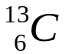
e  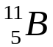 | f  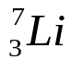 | g  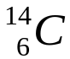 | h  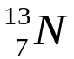
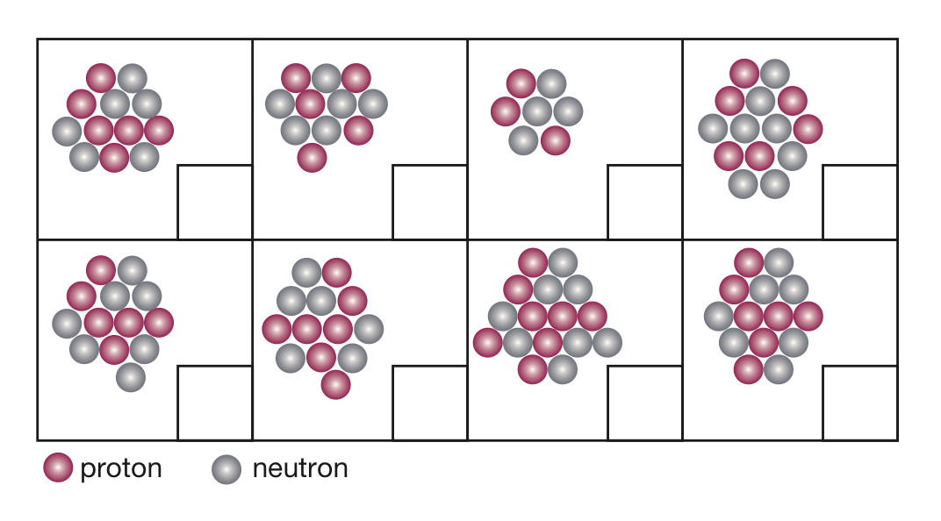
Figure 7.3.2

2 Draw the nucleus represented by each atomic symbol.
a  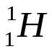 |  | b  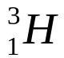
c  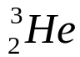 |  | d  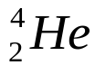
3 Explain what is wrong with each of the following atomic symbols.
a
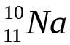

b
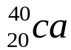

c
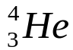

Atoms have no electric charge. In other words they are charge neutral. This is because there is always an equal number of protons (charge +1) and electrons (charge -1).
The electrons are confined to electron shells that surround the nucleus like the layers of an onion. The first (inner-most) electron shell is the smallest and can only hold a maximum of 2 electrons. The second electron shell is slightly bigger so can hold a maximum of 8 electrons. The third electron shell is even bigger and can hold a total of 18 electrons.
4 Determine how many electrons need to be added to each of the electron shell diagrams in Figure 7.3.3 to make the atoms neutral.
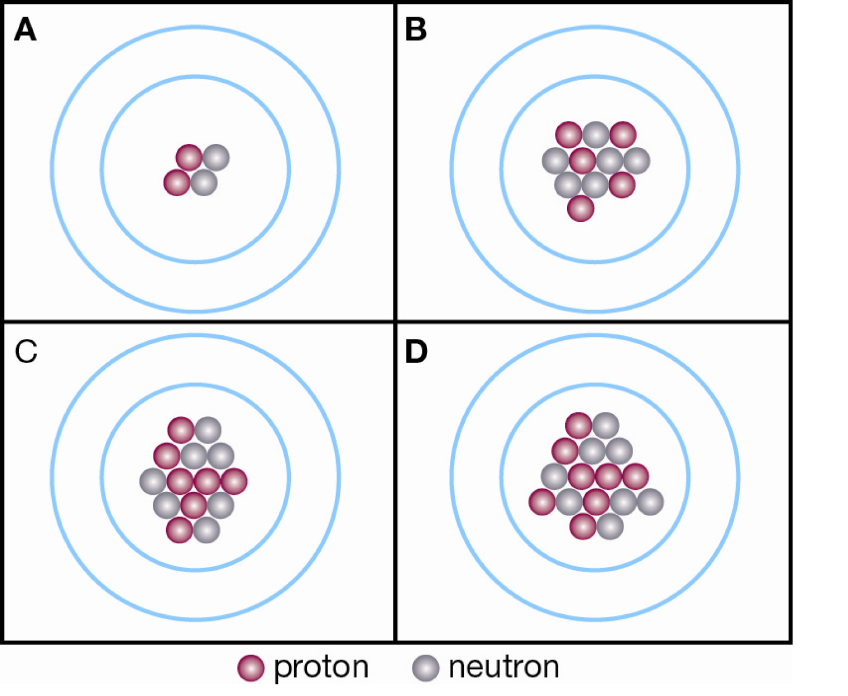
Figure 7.3.3

